Department of Marathi
Overview
Department of Marathi has been established with the vision of conservation of Indian culture, literature, and regional language, as well as promotion of the mother language in all sectors of human life. It offers graduate programme B.A. Marathi since 2002, and M.A. Marathi since 2021, The department aims to promote Marathi language & culture and study its history. There are 2 faculty members. The future complex will have a library, seminar rooms, and research cubicles. The department has a valuable collection of manuscripts and is actively collecting more.
Objectives
To create interest in Marathi language and literature among students.
To encourage creative usage of Marathi language.
To encourage applied usage of Marathi and thereby to enhance employability.
To encourage learners to create modern literature.

- VISION

- *To develop personality development

- * To develop essential skills and potential in students for building up knowledge oriented society

- MISSION

- *To provide opportunities for widening the vision of rural youth and make them competent and responsible citizen of India

Achievements
Awards, news
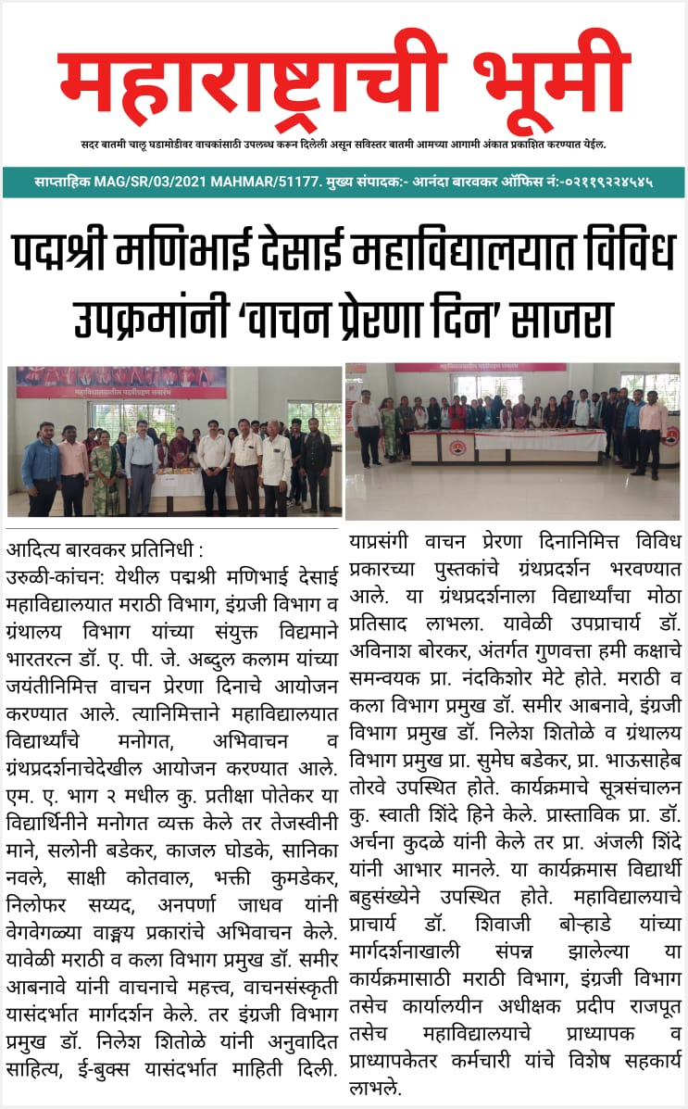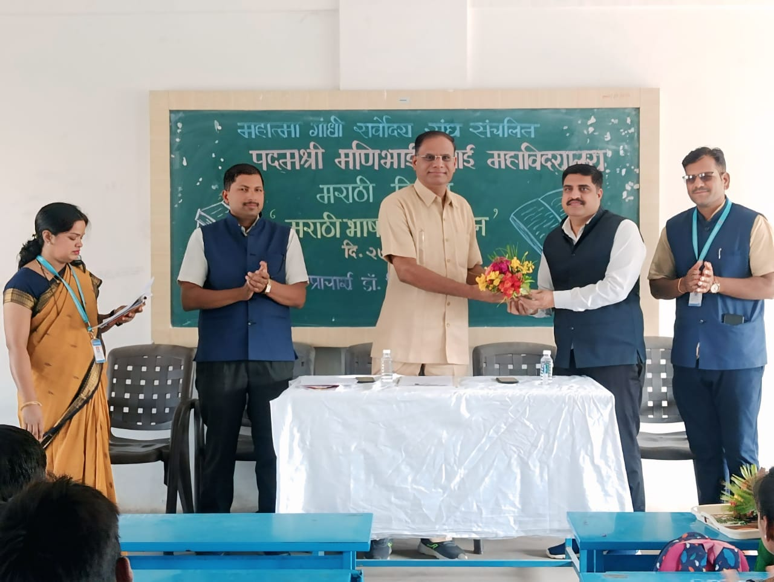

Features
Department Highlights

- Chapter in Books by professors in the department have been published.
- The professors of the department have Ph.D
- The professors of the department have published state, national and international research papers.

Departmental Profile
Sr.No. | Name of Faculty | Designation |  | Qualification |  | Experience in Year
1 | Dr. Abnave S.V. | Head of Department  Assistant Prof. | MA. SET, PhD |  | 23
2 | Prof. Pawar S.U. | Assistant Prof. | MA. B.Ed.SET |  | 03

Best Practices
Sr. No. | Name of the File | File Link

Poster Presentation - Index, Notice., Presntee, Photo, report, News
Marathi Bhasha Pandharwada

Activities
Marathi Bhasha Pandharwada
Vachan Prerna Din
Participation in Vishv sahitya sanmelan Pune
Marathi Bhasha Gaurav Din

Career
Marathi subject rojgar sandhi

Eligibility Criteria

Sr. No. | Name of the Course | Eligibility Criteria
1 | BA | 12th
2 | MA | BA

Rules & Regulation

Strength & Opportunities

Co & Po

Syllabus

Department Activities
- Talk Media
- Street Play
- Books Exhibition
- Various Writing workshop
- World Marathi Day
- Reading Inspiring Day
- Wall Paper & Poster Presentation
- Quiz, Debate, Poems, Book Review Competition
- Interview of Writers and Critics
- Group Discussion
- Various Short Term Courses
- Seminars

Result Analysis

Sr. No. | Class | Paper | 2021-22 | 2022-23 | 2023-24 | 2024-25 | 2025-26
1 | TYBA | G3 | 68% | 100% | 100% | 93%
 |  | S3 | 89% | 91% | 90.90% | 100%
 |  | S4 | 100 | 100 | 100 | 100%
2 | MA II |  |  |  | 75% | 100%

Research Paper Publication
Sr. No. | Title with page Nos. | Journal / Pros |  | ISSN / ISBN No. | Level
1 | कैकाडी समाज- एक दृष्टिक्षेप( पान नंबर 32) |  | Power Of Knowledge | ISSN-2320-4439 | International
2 | इंदिरा संत यांचे ललित लेखन ( पान नंबर 217) |  | CTBS INTERNATIONAL RESEARCH JOURNAL | ISSN-2350-0905 | International
3 | माहिती तंत्रज्ञान व इंटरनेटवरील दैनिके ( पान नंबर 74) |  | VIDYAVARTA | ISSN:2319 9318 | International
4 | कादंबरी साहित्याचे चित्रपट माध्यमांतर |  | VIDYAVARTA | ISSN:2319 9318 | International

Research Work in Faculty

Sr.No. | Name of Faculty | Degree | Research Title
1 | Dr. Abnave S.V. | PH.D. | भटक्या विमुक्त समाजाचे चित्रण करणारी मराठी कादंबरी :वाड्मयीन व समाजशास्त्रीय अभ्यास

Sr. No. | Title of the paper presented | Title of Conference / Seminar | Organized By | Place | Whether international / National / State / Regional / College or University Level
1 | ग्रामीण कादंबरीतील दुष्काळातीलचित्रण | दुष्काळाचे मराठी साहित्यातील प्रतिबिंब | समाजभूषण गणपतराव काळभोर महा विद्यालय लोणी काळभोर | लोणी काळभोर | राज्यस्तरीय
2 | बदलते सांस्कृतिक पर्यावरण व मराठी दलित कथा | बदलते सांस्कृतिक पर्यावरण आणि मराठी कथा | शंकरराव भेलके महाविद्यालय नसरापूर | नसरापुर | राष्ट्रीय
3 | इंदिरा संत यांचे ललित लेखन | बृहन्महाराष्ट्रातील साहित्यिकांचे मराठी भाषा आणि साहित्य यांना योगदान | चांद मल ताराचंद बोरा महाविद्यालय शिरूर | शिरूर | आंतरराष्ट्रीय परिषद
4. | मराठी कवितेतील पर्यावरणीय जाणीवा | International conference on ‘ sustainable Devwlopment: Solution for the Future | पद्मश्री मणिभाई देसाई महाविद्यालय उरुळी कांचन | उरुळी कांचन | आंतरराष्ट्रीय परिषद

Contributory / edited Book : Chapters Published / Editor / member of editorial board

Sr. No. | Name of the book and Topic / Chapter | Type of Book Text / Ref. / Distance
1 | साहित्यकृतीचा आस्वाद/ रारंगढांग कादंबरीतील वातावरणनिर्मिती , रारंगढांग कादंबरीचे वेगळेपण | Reference-

Scholar List
Sr.No. | Student Name | Academic Year | Percentage
1 | Daundkar Rutvika Mohan | 2021-22 | 77.25%
2 | Potekar Pratiksha Nagesh | 2022-23 | 73.42%
3 | Bhosale Shreya Vijay | 2023-24 | 62.12%
4 | Choudhari Namrta Shivaji | 2024-25 | 71.02%

